**Chapter 1 – The Nature of Science**

Section 2 – Standards of Measurement

About how much is 1 kilogram? _____________ It’s hard to say, that’s why there needs to be a standard

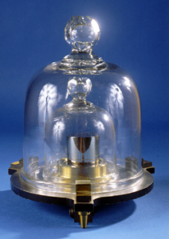

* A STANDARD is an ____________________ that people ______________

________________to compare measurements

* National prototype kilogram K20, one of two prototypes

stored at the US National Institute of Standards and Technology

in Gaithersburg, Maryland

* Two systems of measurement:

**English Metric – (*SI units – International System*)**

* Examples: (SI units underlined)
  + **Length** – _________ (milli, centi, kilo)
  + **Volume** – ______________ (milli, kilo)
  + **Temperature** – ____________ (not indicated by degrees)
  + **Mass** – ________________ (milli, kilo)
  + **Time** – ____________, minutes, hours
* What makes this a better system?
  + Converting between units is _______________, because it is in

**MULTIPLES of __________**

* Examples:
  + Length – feet, yards, miles
  + Volume – gallons, cups, quarts, cubic feet/inches
  + Temperature - degrees Fahrenheit or Celsius
  + Weight – pounds, ounces
  + Time – seconds, minutes, hours
* What makes this system difficult?
  + ________________________
  + What makes converting so easy in the metric system?

USING **________________** that represent the ________________ of the unit (multiples of 10)

* + So we simply move the _________________ right or left depending on what we are starting with and where we are going to
    - Move it _______ if you are converting from a large unit to a smaller unit (the number will get ______________)
    - Move it ___________ if you are converting from small unit to a larger unit (the number will get __________________)
    - This is accomplished by **________**

**______________________ by 10s**

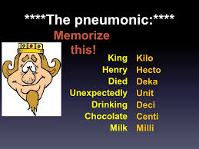

________________________________________________________

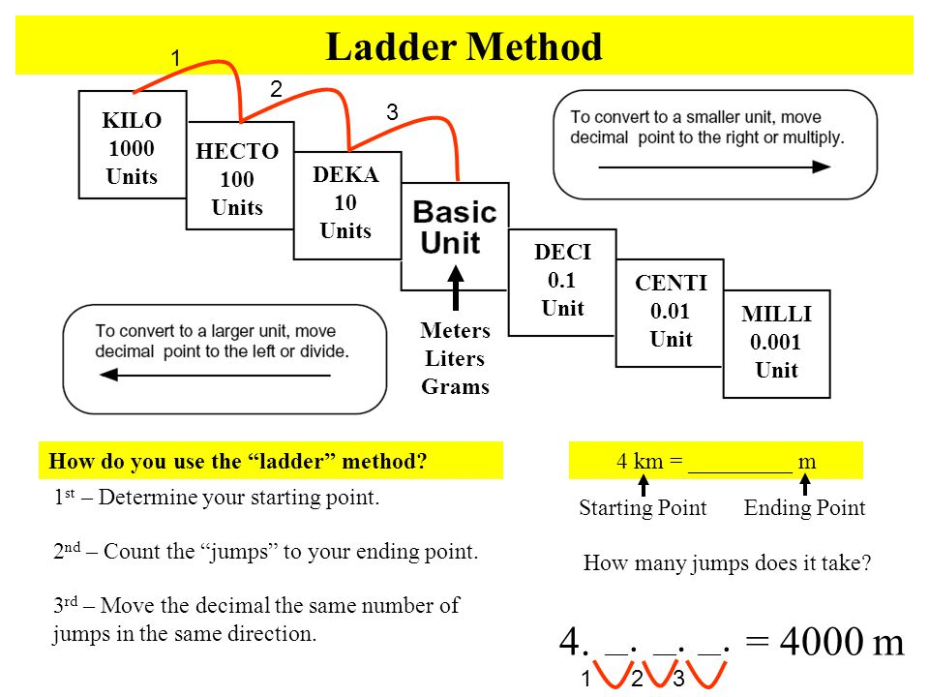

Examples: Practice converting

Convert 3.2 L to mL

Answer – **____________**

Convert 5380 mg to g

Answer - **____________**

Convert 2.32 km to cm

Answer – **____________**

Definition review:



**Matter** – anything that has ____________________________

**Volume** – the ____________________ an object ___________

**Mass** – the __________________________________ an object

**Density** – ______________________________________

Density = ________________________________

Density is a **derived unit** – it is made up of ________________________ unit, like cm2 or mi/hr

Example: What is the density of a wood block with a mass of 500g and it takes up 2.5 liters of space? ____________________________________

**Temperature** – Kelvin is the SI unit of temperature (no degrees when using Kelvin)

Kelvin = _______________________

Celsius = ⁵⁄₉(°F – 32)

Fahrenheit = ⁹⁄₅°C + 32

Convert standard body temp to °Celsius, then to Kelvin

_____________________________________________________________